MASCHERPA Audric ROB 3 2022 / 2023

**POLY-SNAKE**

**Meeting report n°2 from 18/10/22 :**

First of all, the beginning of this second session was about the choice of position maintenance for servomotors. Indeed, during the last session, the chosen solution was the use of ball bearing but the use of a simple cylinder piece for the maintenance in position is sufficient.

Figure 2.1

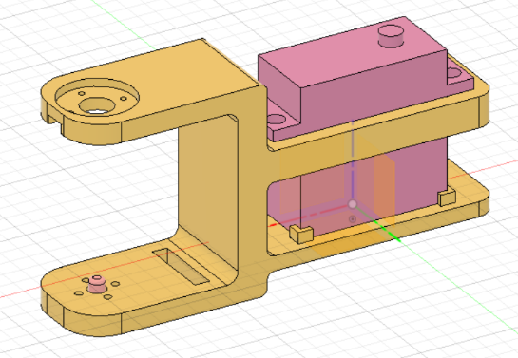

Thus, we chose to leave the ball bearing and use the simplest idea. Then, I forgot the idea of making the wooden piece because of the lack of time, so I chose to upgrade the design the 3d piece during this session. (Figure 2.1). This piece can accommodate a servomotor and keep it in position while allowing stable rotation using the pink piece (in the left of the picture).

Figure 2.2

Next, I printed the piece using PETG filament as explain in the bibliography as show the figure 2.2. Unfortunately, due to a lack of precision in the machine, the part does not allow the servomotor to be accommodated. Thus, the next session will focus on the modification of the part as well as the implementation of some new features such as supports for the wheels

Finally, it was decided with my project partner to use the TD-8135MG model as a servomotor because it was closer to our performance requirements than the one chosen at the previous session.